Project Planning Phase
Project Planning Template (Product Backlog, Sprint Planning, Stories, Story points)

Date | 18 October 2026
Team ID | PNT2022TMIDxxxxxx
Project Name | EV Market Analysis (Tableau)
Maximum Marks | 8 Marks

Product Backlog, Sprint Schedule, and Estimation (4 Marks)
Use the below template to create product backlog and sprint schedule
Sprint | Functional Requirement (Epic) | User Story Number | User Story / Task | Story Points | Priority | Team Members
Sprint-1 | Data Preparation | USN-1 | As an analyst, I can load ev_market_train.csv into Tableau so that I can analyze all vehicles. | 3 | High | Project Lead
Sprint-1 |  | USN-2 | As an analyst, I can remove the duplicate row so that counts and sums are accurate. | 2 | High | Project Lead
Sprint-1 |  | USN-3 | As an analyst, I can see null counts for key columns so that I know which averages to trust. | 2 | Medium | Project Lead
Sprint-1 | Project Setup | USN-20 | Set up the Tableau project, project folder, and GitHub repository. | 3 | High | Project Lead
Sprint-1 | Calculated Fields | USN-21 | Create calculated fields: Est Revenue, Price per km, Battery Health %, Charging Band, and Vehicle Type. | 3 | High | Project Lead
Sprint-2 | Market Dashboard | USN-4 | As an analyst, I can view KPI cards for total vehicles, total sales, average price, average range, and average rating. | 3 | High | Project Lead
Sprint-2 |  | USN-5 | As an analyst, I can see the top 10 manufacturers by annual sales. | 2 | High | Project Lead
Sprint-2 |  | USN-6 | As an analyst, I can see regional market share. | 2 | High | Project Lead
Sprint-2 | Product & Battery Analysis | USN-7 | As an analyst, I can compare battery degradation by battery type. | 3 | Medium | Project Lead
Sprint-2 |  | USN-8 | As an analyst, I can see price vs range by category. | 3 | Medium | Project Lead
Sprint-2 | Filters & Interaction | USN-11 | As an analyst, I can filter by region, category, and model year across all sheets. | 3 | High | Project Lead
Sprint-2 |  | USN-12 | As an analyst, I can click a manufacturer and have the other sheets update. | 2 | Medium | Project Lead
Sprint-3 | Product & Battery Analysis | USN-9 | As an analyst, I can see how charging speed relates to charging band. | 2 | Medium | Project Lead
Sprint-3 |  | USN-10 | As an analyst, I can see price and range trends from 2018 to 2026. | 2 | Medium | Project Lead
Sprint-3 | Story & Publishing | USN-13 | As an analyst, I can build a 5-point story explaining the market. | 3 | Medium | Project Lead
Sprint-3 |  | USN-14 | As an analyst, I can publish the dashboard to Tableau Public and share the link. | 3 | High | Project Lead
Sprint-3 | Vehicle Comparison | USN-15 | As a first-time buyer, I can compare range, price, and charging time for two categories. | 3 | Medium | Project Lead
Sprint-3 |  | USN-16 | As a buyer, I can see recommended use cases (city, family, long-distance). | 2 | Low | Project Lead
Sprint-3 | Access & Reporting | USN-17 | As a manager, I can open the dashboard from a link without installing Tableau. | 2 | High | Project Lead
Sprint-3 |  | USN-18 | As a manager, I can read the story to understand the key insights in under 5 minutes. | 2 | Medium | Project Lead
Sprint-3 | Project Maintenance | USN-19 | As the project admin, I can keep the GitHub repo updated with data, screenshots, and README. | 1 | Low | Project Lead

Project Tracker, Velocity & Burndown Chart: (4 Marks)
Sprint | Total Story Points | Duration | Sprint Start Date | Sprint End Date (Planned) | Story Points Completed (as on Planned End Date) | Sprint Release Date (Actual)
Sprint-1 | 13 | 6 Days | 2 Nov 2026 | 7 Nov 2026
Sprint-2 | 18 | 6 Days | 9 Nov 2026 | 14 Nov 2026
Sprint-3 | 20 | 6 Days | 16 Nov 2026 | 21 Nov 2026

Velocity:
Imagine we have a 10-day sprint duration, and the velocity of the team is 20 (points per sprint). Let’s calculate the team’s average velocity (AV) per iteration unit (story points per day)
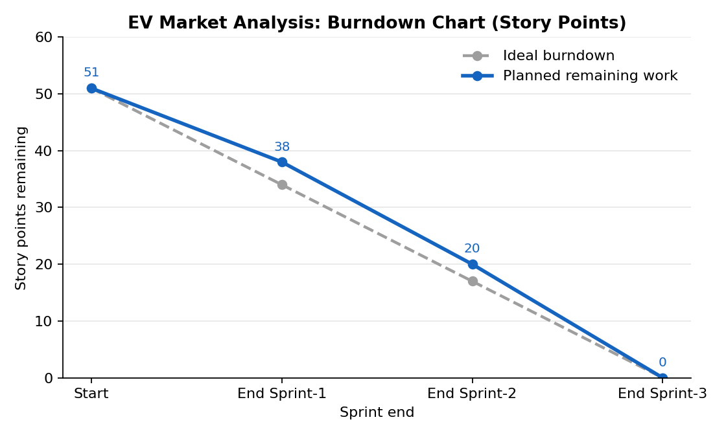
Our project: total story points = 51 across 3 sprints (13 + 18 + 20). Average velocity (AV) = 51 / 3 = 17 points per sprint. Per day (6-day sprint): 17 / 6 = 2.83 story points per day.

Burndown Chart:
A burn down chart is a graphical representation of work left to do versus time. It is often used in agile software development methodologies such as Scrum. However, burn down charts can be applied to any project containing measurable progress over time.

https://www.visual-paradigm.com/scrum/scrum-burndown-chart/
https://www.atlassian.com/agile/tutorials/burndown-charts

Reference:
https://www.atlassian.com/agile/project-management
https://www.atlassian.com/agile/tutorials/how-to-do-scrum-with-jira-software
https://www.atlassian.com/agile/tutorials/epics
https://www.atlassian.com/agile/tutorials/sprints
https://www.atlassian.com/agile/project-management/estimation
https://www.atlassian.com/agile/tutorials/burndown-charts

